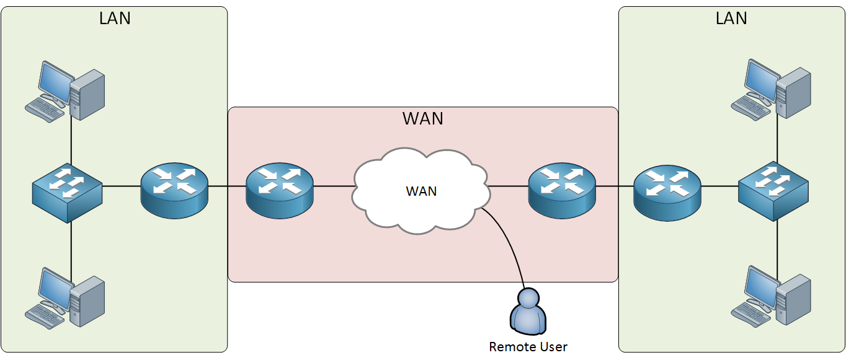

**LAN (Local Area Network):**

A LAN connects devices like computers, printers, and phones within a small area like a home, school, or office using switches and routers.

**Example**: In a school computer lab, all the computers connected together to share files and printers form a LAN.

**WAN (Wide Area Network):**

A WAN connects multiple LANs over large geographical areas through the internet or private networks.

**Example**: When your school computers access a website hosted in another country, it uses the WAN (internet) to reach that server.